**LABSHEET 2: ASSEMBLY LANGUAGE PROGRAMMING OF**

**8085 MICROPROCESSORS**

**__________________________________________________________________________**

**Name: ASWIN G MENON Roll Number: AM.EN.U4CSE20313**

**___________________________________________________________________________**

# ONE’S COMPLEMENT OF AN 8-BIT NUMBER

|  |  |  |  |
| --- | --- | --- | --- |
| **INPUT** |  | **OUTPUT** |  |
| Memory location | Data | Memory location | Data |
| 5100H | 40 | 5101H | 215 |

# 2’S COMPLEMENT OF AN 8-BIT NUMBER

|  |  |  |  |
| --- | --- | --- | --- |
| **INPUT** |  | **OUTPUT** |  |
| Memory location | Data | Memory location | Data |
| 5100H | 40 |  | 216 |

1. Show the output in 8085 simulator for the following programs. Attach the screenshot of final status of PC and relevant registers.
   1. **Copy 10 numbers stored from the location 2050H to the new location**

**2070H**

* 1. **8-bit Addition without carry**

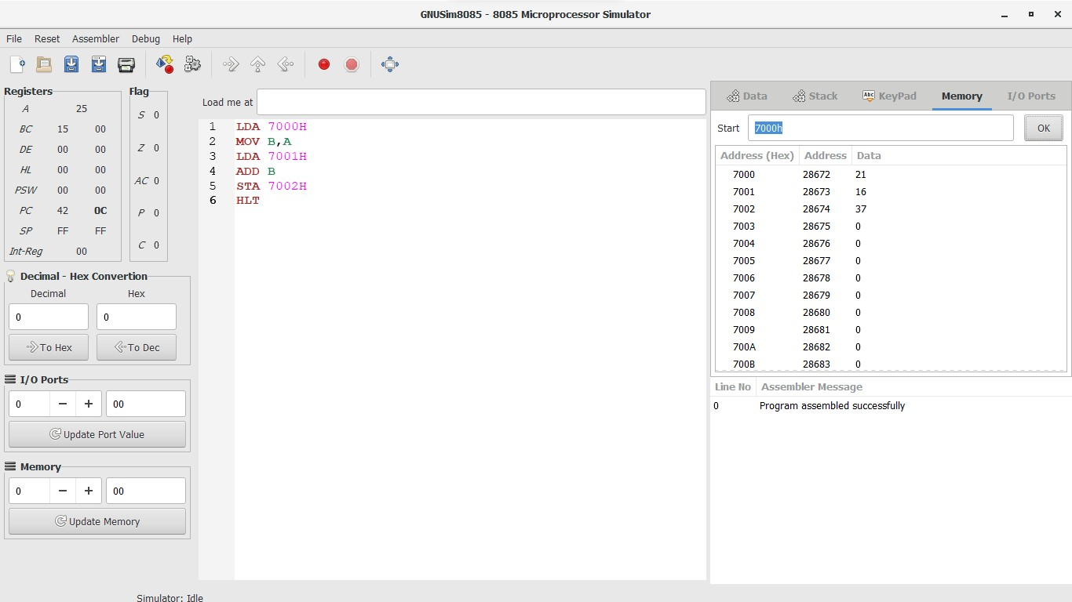

* 1. **8-bit Addition with carry**

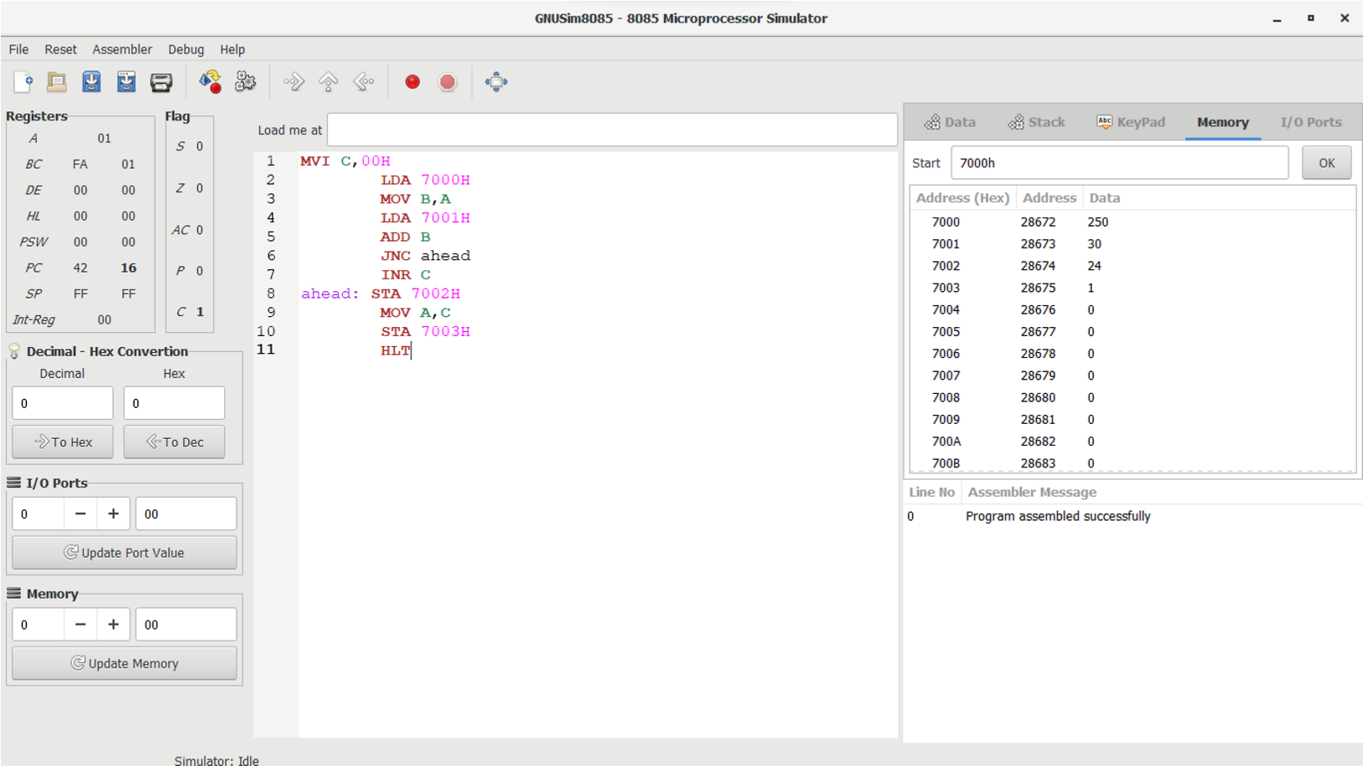

* 1. **8-bit Subtraction**

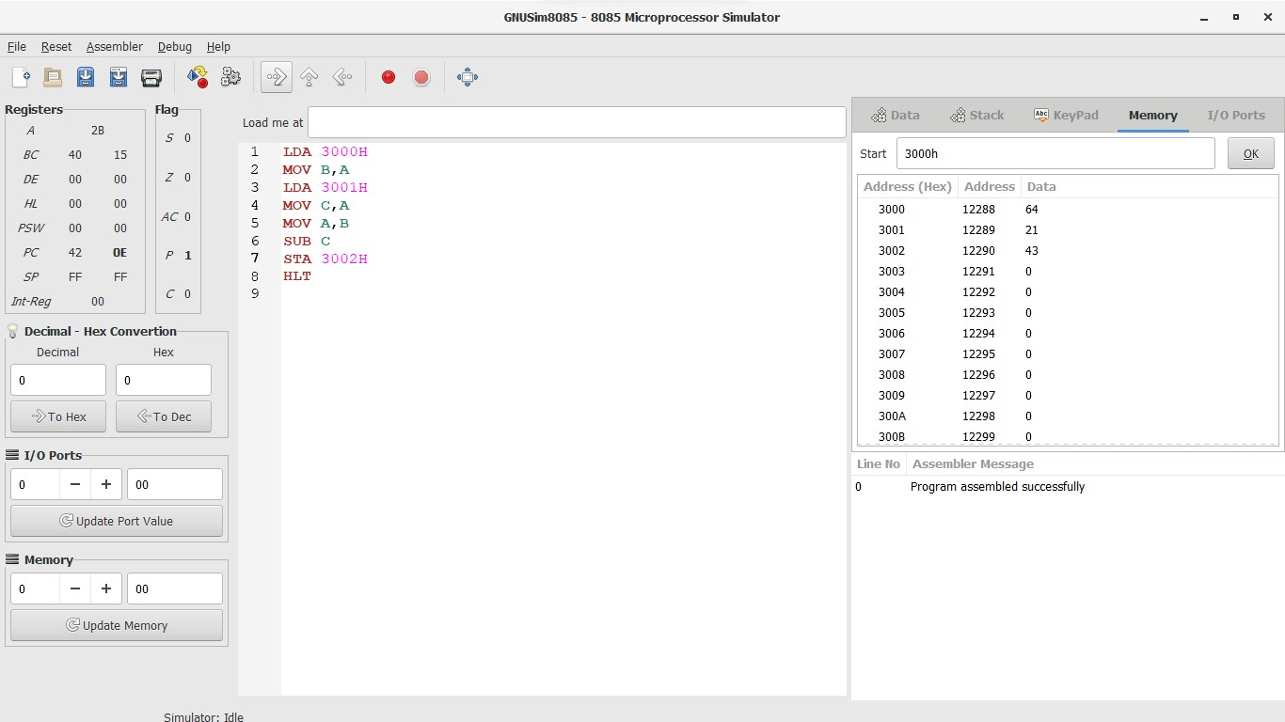

* 1. **8-bit Multiplication**

;Multiplying 2 numbers 12H and 03H

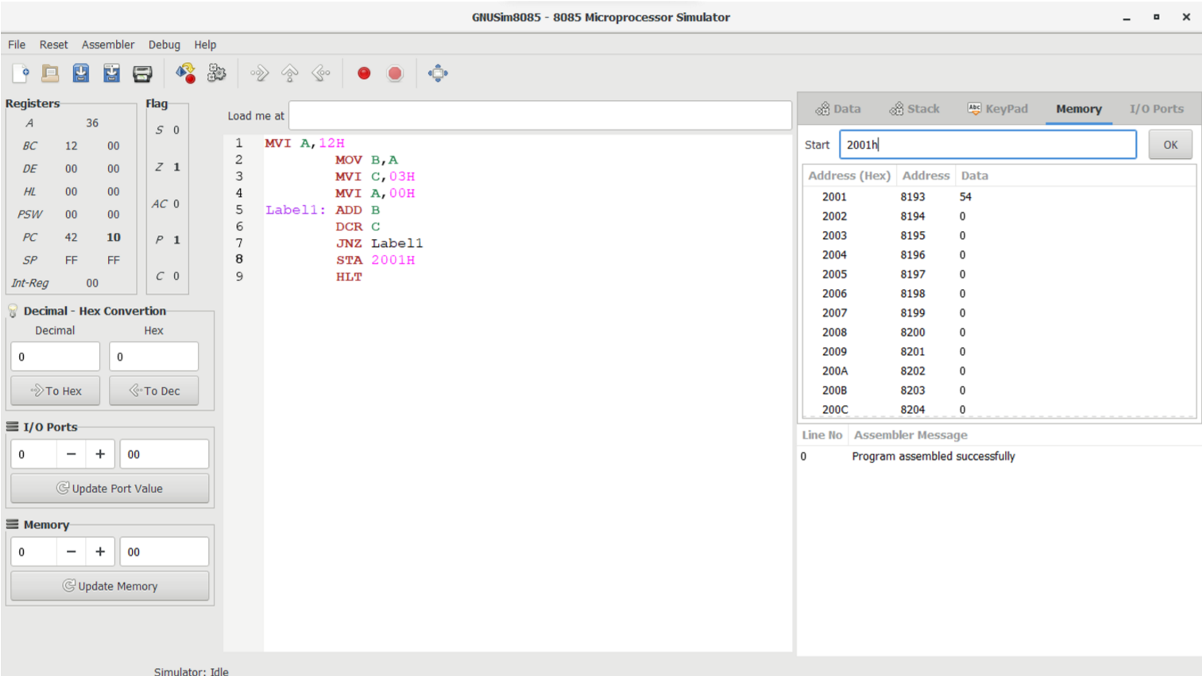

* 1. **8-bit Division**

;Division of 2 numbers : Dividend -> 4AH & Divisor -> 08H

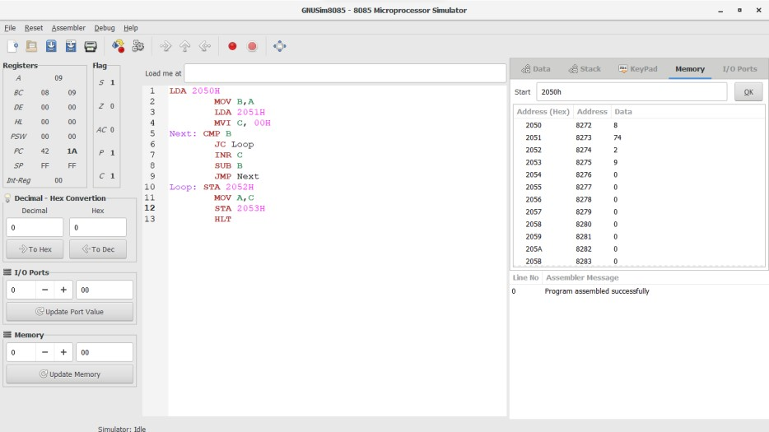

* 1. **16-bit Addition**

;Addition of 2 numbers 1020H & 2040H

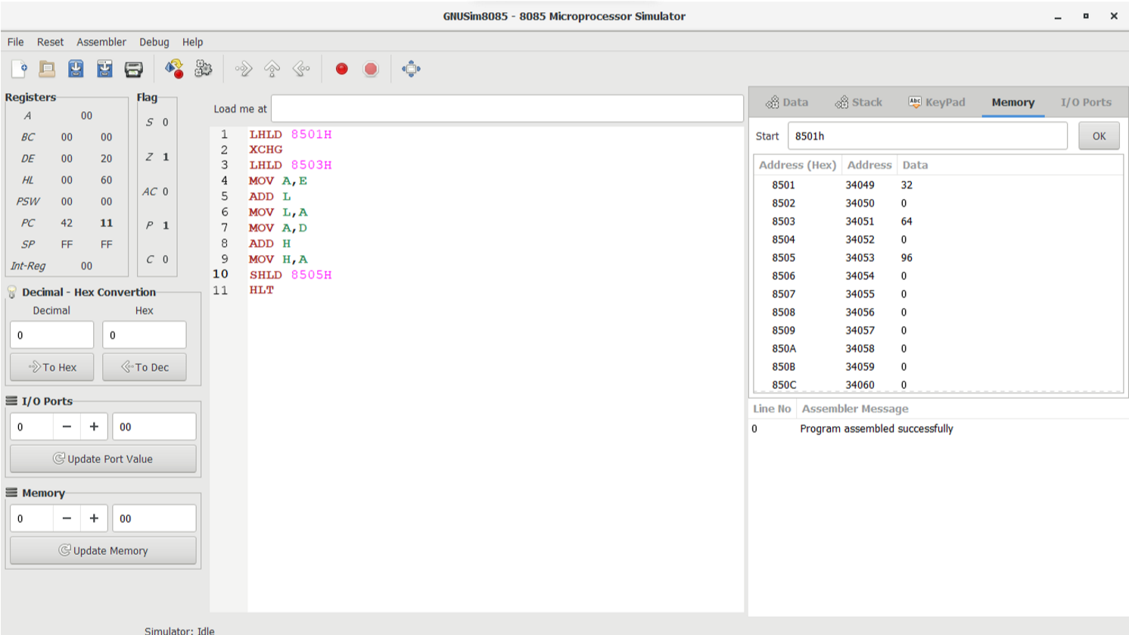

* 1. **16-bit Subtraction**

;Subtraction of 2 numbers 2040H & 1020H

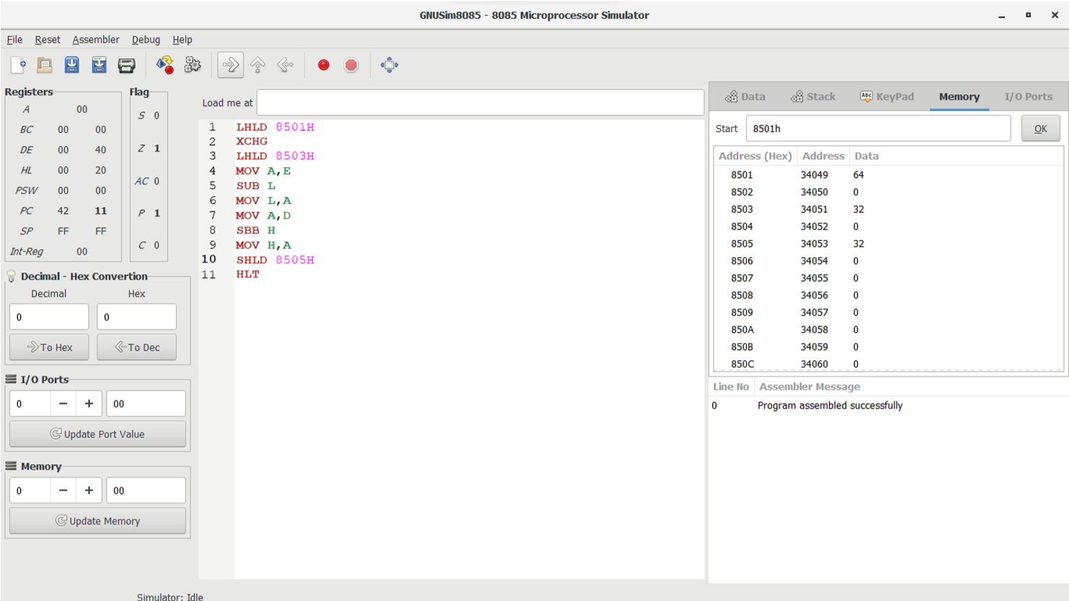

1. Write an assembly program in mnemonic code for 8085 processor to calculate

(A+B)-C where the value of

* + - A stored the value 34H at address 2300H
    - B stored the value 47H at address 2301H
    - C stored the value ABH at address 2302H

